CORRELATIONS
/VARIABLES=Skill_Moves Attacking_Position
/PRINT=TWOTAIL NOSIG
/MISSING=PAIRWISE.

Correlations

Notes
Output Created |  | 14-FEB-2019 13:55:43
Comments
Input | Active Dataset | DataSet1
Input | Filter | <none>
Input | Weight | <none>
Input | Split File | <none>
Input | N of Rows in Working Data File | 17588
Missing Value Handling | Definition of Missing | User-defined missing values are treated as missing.
Missing Value Handling | Cases Used | Statistics for each pair of variables are based on all the cases with valid data for that pair.
Syntax |  | CORRELATIONS  /VARIABLES=Skill_Moves Attacking_Position  /PRINT=TWOTAIL NOSIG  /MISSING=PAIRWISE.
Resources | Processor Time | 00:00:00.05
Resources | Elapsed Time | 00:00:00.06

Correlations
 |  | Skill_Moves | Attacking_Position
Skill_Moves | Pearson Correlation | 1 | .720**
Skill_Moves | Sig. (2-tailed) |  | .000
Skill_Moves | N | 17588 | 17588
Attacking_Position | Pearson Correlation | .720** | 1
Attacking_Position | Sig. (2-tailed) | .000
Attacking_Position | N | 17588 | 17588

**. Correlation is significant at the 0.01 level (2-tailed).

GRAPH
/SCATTERPLOT(BIVAR)=Attacking_Position WITH Skill_Moves
/MISSING=LISTWISE.

Graph

Notes
Output Created |  | 14-FEB-2019 13:56:56
Comments
Input | Active Dataset | DataSet1
Input | Filter | <none>
Input | Weight | <none>
Input | Split File | <none>
Input | N of Rows in Working Data File | 17588
Syntax |  | GRAPH  /SCATTERPLOT(BIVAR)=Attacking_Position WITH Skill_Moves  /MISSING=LISTWISE.
Resources | Processor Time | 00:00:00.59
Resources | Elapsed Time | 00:00:00.61

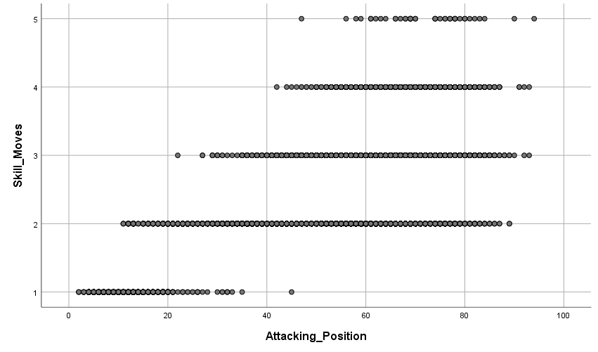

Notes
Output Created |  | 14-FEB-2019 13:57:45
Comments
Input | Active Dataset | DataSet1
Input | Filter | <none>
Input | Weight | <none>
Input | Split File | <none>
Input | N of Rows in Working Data File | 17588
Syntax |  | GRAPH  /SCATTERPLOT(BIVAR)=Skill_Moves WITH Attacking_Position  /MISSING=LISTWISE.
Resources | Processor Time | 00:00:00.59
Resources | Elapsed Time | 00:00:00.59

Notes
Output Created |  | 14-FEB-2019 13:59:44
Comments
Input | Active Dataset | DataSet1
Input | Filter | <none>
Input | Weight | <none>
Input | Split File | <none>
Input | N of Rows in Working Data File | 17588
Missing Value Handling | Definition of Missing | User-defined missing values are treated as missing.
Missing Value Handling | Cases Used | Statistics are based on cases with no missing values for any variable used.
Syntax |  | REGRESSION  /MISSING LISTWISE  /STATISTICS COEFF OUTS R ANOVA  /CRITERIA=PIN(.05) POUT(.10)  /NOORIGIN  /DEPENDENT Attacking_Position  /METHOD=ENTER Skill_Moves.
Resources | Processor Time | 00:00:00.08
Resources | Elapsed Time | 00:00:00.13
Resources | Memory Required | 5008 bytes
Resources | Additional Memory Required for Residual Plots | 0 bytes

REGRESSION
/MISSING LISTWISE
/STATISTICS COEFF OUTS R ANOVA
/CRITERIA=PIN(.05) POUT(.10)
/NOORIGIN
/DEPENDENT Attacking_Position
/METHOD=ENTER Skill_Moves
/SAVE ZRESID.

Regression

Notes
Output Created |  | 14-FEB-2019 14:01:31
Comments
Input | Active Dataset | DataSet1
Input | Filter | <none>
Input | Weight | <none>
Input | Split File | <none>
Input | N of Rows in Working Data File | 17588
Missing Value Handling | Definition of Missing | User-defined missing values are treated as missing.
Missing Value Handling | Cases Used | Statistics are based on cases with no missing values for any variable used.
Syntax |  | REGRESSION  /MISSING LISTWISE  /STATISTICS COEFF OUTS R ANOVA  /CRITERIA=PIN(.05) POUT(.10)  /NOORIGIN  /DEPENDENT Attacking_Position  /METHOD=ENTER Skill_Moves  /SAVE ZRESID.
Resources | Processor Time | 00:00:00.08
Resources | Elapsed Time | 00:00:00.09
Resources | Memory Required | 5008 bytes
Resources | Additional Memory Required for Residual Plots | 0 bytes
Variables Created or Modified | ZRE_1 | Standardized Residual

Variables Entered/Removedª
Model | Variables Entered | Variables Removed | Method
1 | Skill_Moves^{b} | . | Enter

a. Dependent Variable: Attacking_Position
b. All requested variables entered.

Model Summary^{b}
Model | R | R Square | Adjusted R Square | Std. Error of the Estimate
1 | .720ª | .518 | .518 | 13.477

a. Predictors: (Constant), Skill_Moves
b. Dependent Variable: Attacking_Position

ANOVAª
Model |  | Sum of Squares | df | Mean Square | F | Sig.
1 | Regression | 3429928.261 | 1 | 3429928.261 | 18885.294 | .000^{b}
1 | Residual | 3193951.708 | 17586 | 181.619
1 | Total | 6623879.969 | 17587

a. Dependent Variable: Attacking_Position
b. Predictors: (Constant), Skill_Moves

Coefficientsª
Model |  | Unstandardized Coefficients |  | Standardized Coefficients | t | Sig.
 |  | B | Std. Error | Beta | t | Sig.
1 | (Constant) | 6.486 | .330 |  | 19.670 | .000
1 | Skill_Moves | 18.716 | .136 | .720 | 137.424 | .000

a. Dependent Variable: Attacking_Position

Residuals Statisticsª
 | Minimum | Maximum | Mean | Std. Deviation | N
Predicted Value | 25.20 | 100.07 | 49.59 | 13.965 | 17588
Residual | -53.067 | 45.082 | .000 | 13.476 | 17588
Std. Predicted Value | -1.746 | 3.614 | .000 | 1.000 | 17588
Std. Residual | -3.938 | 3.345 | .000 | 1.000 | 17588

a. Dependent Variable: Attacking_Position

GRAPH
/SCATTERPLOT(BIVAR)=Skill_Moves WITH ZRE_1
/MISSING=LISTWISE.

Graph

Notes
Output Created |  | 14-FEB-2019 14:02:09
Comments
Input | Active Dataset | DataSet1
Input | Filter | <none>
Input | Weight | <none>
Input | Split File | <none>
Input | N of Rows in Working Data File | 17588
Syntax |  | GRAPH  /SCATTERPLOT(BIVAR)=Skill_Moves WITH ZRE_1  /MISSING=LISTWISE.
Resources | Processor Time | 00:00:00.62
Resources | Elapsed Time | 00:00:00.64

